
Hello to everyone

The battle goes on and a lot has happened this week. We got media coverage on News Talk ZB, the Capital Times and the Upper Hutt Leader. Hopefully we got coverage in your area as well to bring our plight to everyone’s attention – if not we need to get those “Letters to the Editor” in. A few minutes now could save you thousands of dollars in the future.

IT’S YOUR CHOICE
A few in the industry have said we’re wasting our time and nothing will change. Yes we could all sit back and do nothing and watch our livelihoods and the future of the trade go down the drain but why should we? Why should something that we have worked hard to get, our competence, be questioned because someone had a rush of sh*t to the brain. Stepping up to be counted is not compulsory but it does help. It’s up to all of us to get others on board. Encourage others to contact one of us and get on the data base.

paul.luxton@paradise.net allan.day@xtra.co.nz wal.gordon@xtra.co.nz
This week our cause was taken to the streets of Wellington and to the Beehive. Wal Gordon and his wife Jeen braved the elements and protested outside Solnet House - the home of the PGDB and outside the Beehive - the home of competence.

Southerly blasts and hail didn’t stop the pair from giving the message to the public, Board members, government employees and the Governor of the Reserve Bank, who happened to walk past.

Silent Protest


The awards from bottom left clockwise,
Dumb Shit ---- DBH, can only balance zero balances
Bog Father ---- John Key, Makes the final decision but nothing sticks.
Shit for Brains --- Your Pick, Perhaps it’s for all
Rim Reaper --- PGDB causing the death of an industry
Turtle Head --- Maurice Williamson Pull your head in and wait for the threat to leave.


Outside Solnet House the home of the PGDB. Yes it is dark but the
early bird catches the Board napping

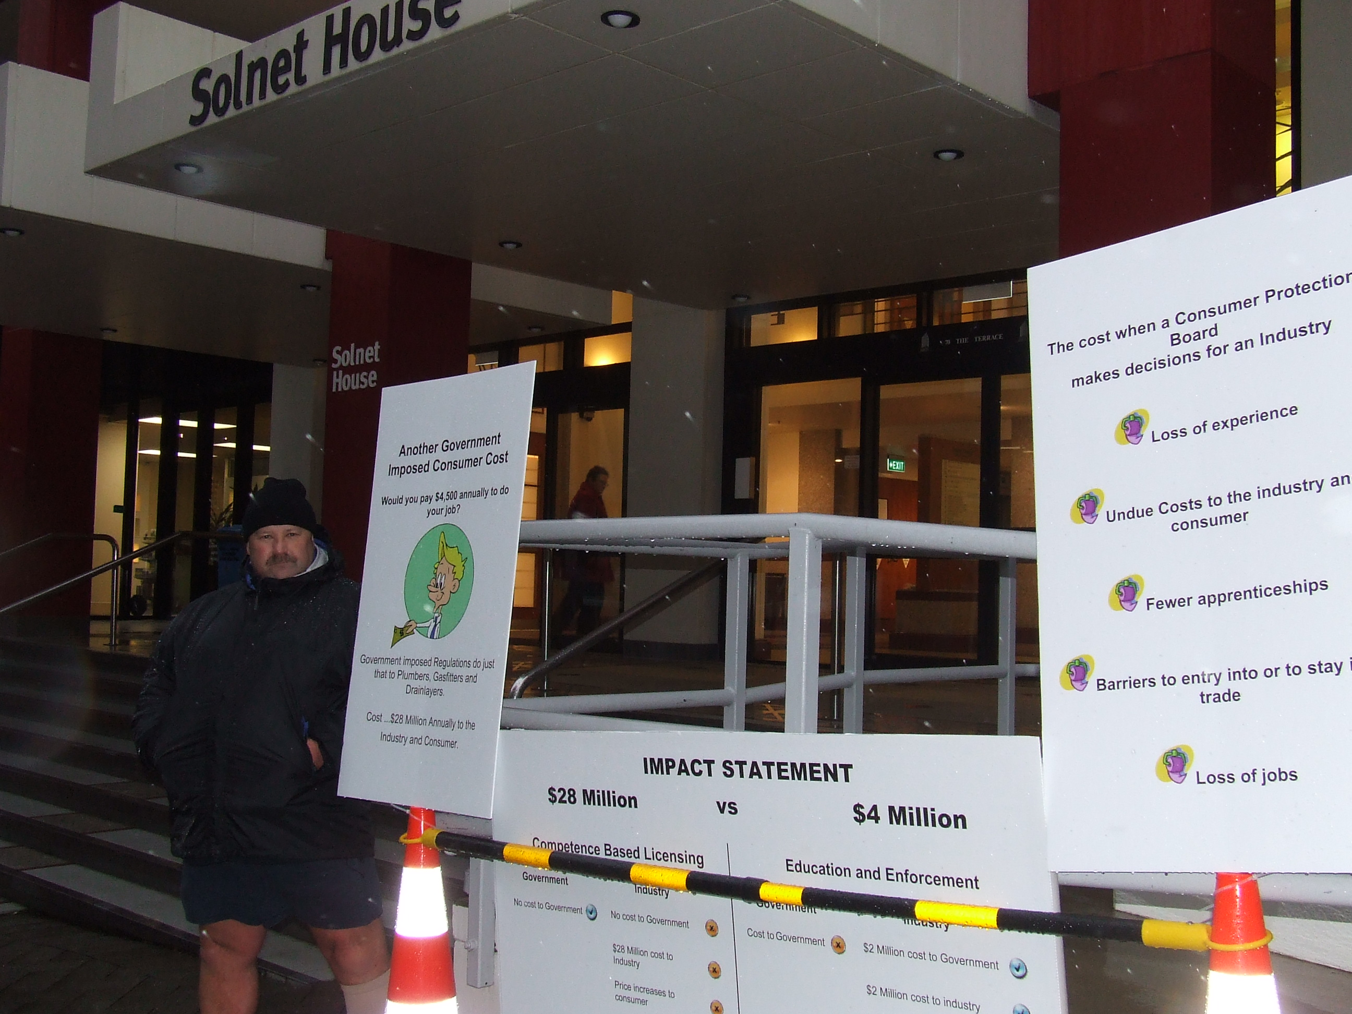

June 2010

issue One

Fellow Practitioners

The Capital Times said:

Wal Gordon is not just angry at the way the Plumbers, Gasfitters, and Drainlayers Board is managed. He is a seriously upset plumber, and he believes the Board should be disestablished.
Capital Times (May 26) reported that Wellingtonian Paul Grant was furious after his complaint to the Board about an “appalling” plumbing job was dismissed, despite the Wellington City Council dissing the job.
After reading the story, plumber Wal Gordon, the owner of Wal Gordon Plumbing Limited in Upper Hutt, contacted us with more concerns.
“[The Board] is not managed well at all,” Gordon says. “I’ve got five A4 folders of concerns, and if you looked through them and saw some of the things they were doing, you’d be in shock.”
Gordon says one of his complaints is currently with the Regulation Review Committee, so he can’t discuss the content, but the Committee has ordered the Plumbers, Gasfitters, and Drainlayers Board to reply by June 30.
His main concern is that in April, the Board ordered all plumbers to undergo Continual Professional Development. He says this will cost consumers $28 million a year.
“By my calculations, it’s going to cost me $4,500 per man, per year,” says Gordon, who employs 10 plumbers. “A lot of self-employed plumbers are not going to be able to foot this cost themselves. It takes away the incentive to take on apprentices, and that will have a huge impact on the industry.”
He sees the Continual Professional Development move as a stepping stone for the Government to guide all licensed practitioners in the construction industry to self-certify their work.
“It will say, ‘now you’re all doing this Continual Professional Development, you’re at a standard where you can certify all your work’. It can then wash it’s hands of any problems,” Gordon says. “Once [the Government] does that, there will be no comeback on it for things like leaky buildings.”
After lodging complaints with the Regulation Review Committee, the Ombudsman, and the Auditor General’s Office, Gordon’s next move is a good old traditional protest.
He will be outside the Plumbers, Gasfitters, and Drainlayers Board head office on The Terrace with plaque cards from 7.30-9am, and outside the Beehive from 11am-2pm, sitting on a toilet pan, June 16 and 17

The Security Guard

While Wal was thanking security at parliament one of the Guards said “do you think you achieved anything?

Wal replied “well no one came out to speak with me but I take that as a positive as they can’t justify what they are doing, either that or they didn’t know I was here”

The guard said “Oh they know you’re here alright. You’re the talk of the building”

Looks like the message is getting out.


The Parking Officer

Parking officer, number 194, whilst giving Wal a parking ticket outside parliament even recognised him and said “You’re the fellow helping us keep the plumbing costs down aren’t you! Good on ya. I feel stink now giving you a ticket” Wal on a high from the positive feedback said “it’s alright mate your only doing your job” and gave to poor chap the entire story, another supporter recruited.
We are trying to promote affirmative action to ensure fairness, equality and standards in Government legislation imposed on licensed practitioners. We need to advocate your position and viewpoints to ensure fairness and equality in regulations imposed by the Government, we want to influence regulatory and legislative outcomes and keep you informed about developments regarding affirmative action and related regulatory changes.

We want to utilise an open consensus process in the development of policy and legislation submissions but need your input so get your details to one of us.

So cold nearly had to put two pair of shorts on, must be a mainlander

Wal spoke with hundreds of people from all walks of life over the three days of protesting and all were supportive. Most could not understand why the industry had to fund the Board. The question was asked of Wal “why don’t they licence you every five years to keep costs down?” Wal's reply “because the Board needs about $4 Million dollars a year to keep their jobs and plumbers wouldn’t pay $3,000 each licence period. So they hit us each year and keep on putting it up so they can get more in small bits. They over charged tradesmen over the last few years and accumulated $1.7 Million to spend as they see fit.”

The message is being heard

The message is being heard

June 2010

issue One

The Board is still claiming 18cents an hour will be the cost of CBL and CPD.

We need to know what your costs are as an individual and for the business owners out there what the cost will be to your business. We want to work on the annual cost and want to come up with some figures to take to the Government.

The type of information we are after is tabled below. Also we would like to know if you do the training after hours or during work hours.

Please send your reply direct to Wal Gordon. Encourage others to do the same.

wal.gordon@xtra.co.nz or PO Box 40 728, Upper Hutt 5140

The PGDB claims Costs of 18cents an hour.

Excerpts from a letter from Maurice Williamson to a plumber dated 16 June 2010

“The board is proposing a small increase in the Disciplinary levy. This reflects the costs of discipline, given the large numbers of licensed and unlicensed practitioners who do not comply with the law. Aside from this, the Board is in fact proposing to redistribute fees between new registrants and existing licence holders to more freely reflect the Board’s costs when undertaking its functions”.

“With regard to continuing professional development, Parliament has agreed that there are significant health and safety risks associated with plumbing, gasfitting and drainlaying. It is the government’s role, through the Board, to ensure plumbers, gasfitters and drainlayers meet nationally accepted standards and remain competent throughout the lifetime of their practice”.

It looks like parliament has deemed we are a risk. We’ll be doing some follow up on this one to find out when and where they agreed to this.

30 June 2010 is an important date where two reports are due.

- PGDB is to report to the Minister with its recommendations about fee increases.

- PGDB is to reply to the regulation review Committee in answer to Wal’s complaint. Wal will then have the chance to respond to their report.

Important date
Licenses Projection for 2012 | Licence and disciplinary fee | Tech points required under CPD | Non Tech Points required under CPD | Number  of 4 point courses | 4 point course $60.00 x number of courses | 4Hrs per course plus travel time x number of courses | Hours x Loss of charge out | Hours x wages | Loss of profit on material | Travel Cost $1.54 per KM
Certifying  Plumbing + Gasfitting+  Drainlaying | $615.00 | 24 | 0 | 6 | $360.00 | 36.00 | $2,867.40 | $ 991.08 | $300.00 | $332.64

Allan Day

Alan is keeping up the pressure on the Government and is meeting on Monday with Darren Hughes. That will hopefully get us the support of have two Horowhenua members of Parliament working together for the Plumbers.

Paul Luxton

Paul has the unfortunate job of compiling a comprehensive mailing list so any help you can give him with this would be much appreciated. Paul is also attending the meeting with Allan.

Wal Gordon

Wal is still collecting information, copies of complaints and general documentation about the activities of the Board. If you have anything you think may be of use then send it to him.

Others

After a meeting last week a number of other people are coming on board to help out. As time goes by their specialist skills will be utilised.

We’ll let you know what they are up to.

What next

What’s Happening Next?

JUNE 2010

issue One

