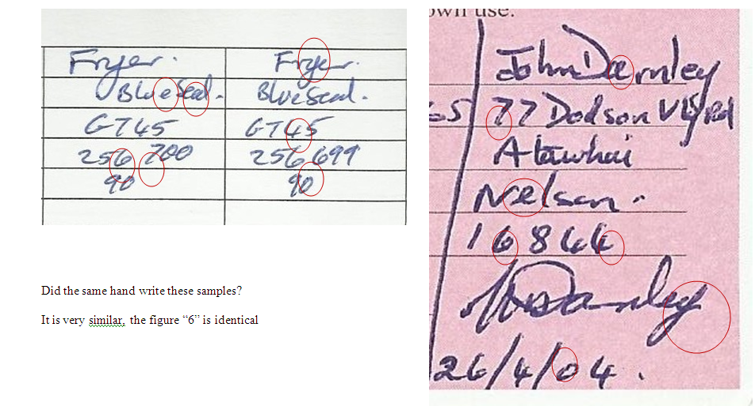

In my unprofessional opinion the writer is the same.
- The start and finish position of the six is the same.
- The Seven has a disincentive kick tail at the bottom
- The Four had a distinctive curl and kick
- The (a) distinctive start point and gap on the tail side
- The (e) as an individual is identical
- The (y) has a distinctive height issue, gap on the upper side of the tail and crossover point of the tail.

